**Project Planning Phase**

**Sprint Delivery Plan**

**TEAM ID :** PNT2022TMID53603

**PROJECT NAME** : IOT BASED SAFETY GADGET FOR CHILD SAFETY MONITORING AND NOTIFICATION

**Product Backlog, Sprint Schedule, and Estimation:**

|  |  |  |  |  |  |  |
| --- | --- | --- | --- | --- | --- | --- |
| **Sprint** | **Functional**  **Requirement**  **(Epic)** | **User Story**  **Number** | **User Story / Task** | **Story**  **Points** | **Priority** | **Team**  **Members** |
| Sprint-1 | Registration | USN-1 | As a user, I can register for the application by entering my email, password and confirming my password. | 4 | High | Kenwin Patrick . A |
| Sprint-1 | Confirmation | USN-2 | As a user, I will receive a confirmation email once I have  registered for the application | 4 | High | Kishore Kumar . T |
| Sprint-2 |  | USN-3 | As a user, I can register for the application through Facebook | 10 | Low | Prasad . E |
| Sprint-1 |  | USN-4 | As a user, I can register for the  application through Gmail | 4 | Medium | Koushik Srinivasan |

|  |  |  |  |  |  |  |
| --- | --- | --- | --- | --- | --- | --- |
| **Sprint** | **Functional**  **Requirement**  **(Epic)** | **User Story**  **Number** | **User Story / Task** | **Story**  **Points** | **Priority** | **Team**  **Members** |
| Sprint-1 | Login | USN-5 | As a user, I can log into the application by entering my email & password | 4 | High | Kishore Kumar . T |
| Sprint-2 | Dashboard | USN-6 | As a User, I can Navigate to the Dashboard after successfully Login to the Application. | 10 | High | Koushik Srinivasan |
| Sprint-1 | Notification | USN-7 | As a user when there is an anomalous situation with the child, a notification will be received through the fencing application. | 4 | High | Kenwin Patrick . A |
| Sprint - 3 | Support | USN-8 | As a User, I can connect with experts to clear Queries, they assist to overcome challenges by scanning for any glitches and monitoring the operation and by checking if all the users are authorized. | 10 | Medium | Prasad . E |
| Sprint - 3 | Login | USN-9 | As an Administrator, I can set the Geofence Location Limit and make sure the database encompassing the locations is secure, factual and updated constantly. | 10 | High | Kenwin Patrick . A |

**Project Tracker, Velocity & Burndown Chart:**

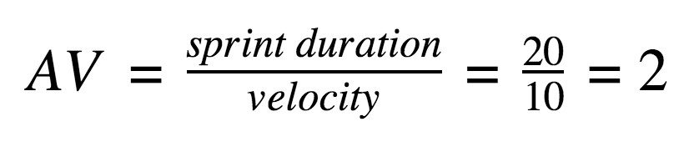

|  |  |  |  |  |  |  |
| --- | --- | --- | --- | --- | --- | --- |
| **Sprint** | **Total Story**  **Points** | **Duration** | **Sprint Start**  **Date** | **Sprint End Date**  **(Planned)** | **Story Points Completed (as on Planned End Date)** | **Sprint Release Date**  **(Actual)** |
| Sprint-1 | 20 | 6 Days | 24 Oct 2022 | 29 Oct 2022 | 20 | 29 Oct 2022 |
| Sprint-2 | 20 | 6 Days | 31 Oct 2022 | 05 Nov 2022 | 20 | 05 Nov 2022 |
| Sprint-3 | 20 | 6 Days | 07 Nov 2022 | 12 Nov 2022 | 20 | 12 Nov 2022 |
| Sprint-4 | 20 | 6 Days | 14 Nov 2022 | 19 Nov 2022 | 20 | 19 Nov 2022 |

**Velocity:**

**Burndown Chart:**

